Mary S. Biesecker Library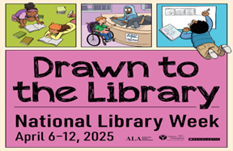

National Library Week Contest 2025

**Draw us a picture of what you love about the library!**

**Official Rules:** Drawing must be on one piece of contest border paper.

You may make as many entries as you have reasons you love the library. **Each** drawing must include a copy of the entry form below and be signed by the artist. There will be one winner from each category.

Contest Categories:

Pre-school- 4 years old and younger

Elementary-Grades K-3

Middle-Grades 4-8

High School-Grades 9-12

Adult

Deadline is Friday, April 5th. All entries must be received by 6 pm in the library located at 230 N. Rosina Avenue, Somerset, PA 15501

Prizes include gift cards and books and will be awarded during National Library Week.

-----------------------------------------------------------------------------------------------------

Name:__________________________ Telephone Number:____________________

Age:______Grade:__________Address:___________________________________

Contest Category (circle one):

Pre-school- 4years old and younger

Elementary-Grades K-3

Middle-Grades 4-8

High School-Grades 9-12

Adult

Parent signature indicating approval of entry and participation (if entrant is under 18 years of age)_________________________________________________________